1. **PC Network TCP/IP Configuration**

**Objective**s:

• Gather information including connection, host name, Layer 2 MAC address and Layer 3 TCP/IP network address information.

• Compare network information to other PCs on the network.

• Learn to use the TCP/IP Packet Internet Groper (ping) command from a workstation.

• Learn to use the Trace Route (tracert) command from a workstation.

**Step 1 Connect into the Internet**

Establish and verify connectivity to the Internet. This ensures the computer has an IP address.

**Step 2 Gather TCP/IP configuration information**

Use the Start menu to open the Command Prompt, an MS-DOS-like window. Press Start >

Programs > Accessories > Command Prompt

OR

Start > Programs > Command Prompt.

OR

Press Start>Run Then type cmd.

The following figure shows the Command screen. Type ipconfig and press the Enter key. The

spelling of ipconfig is critical while case is not. It is short for IP Configuration.

Fig.1: Command Screen for ipconfig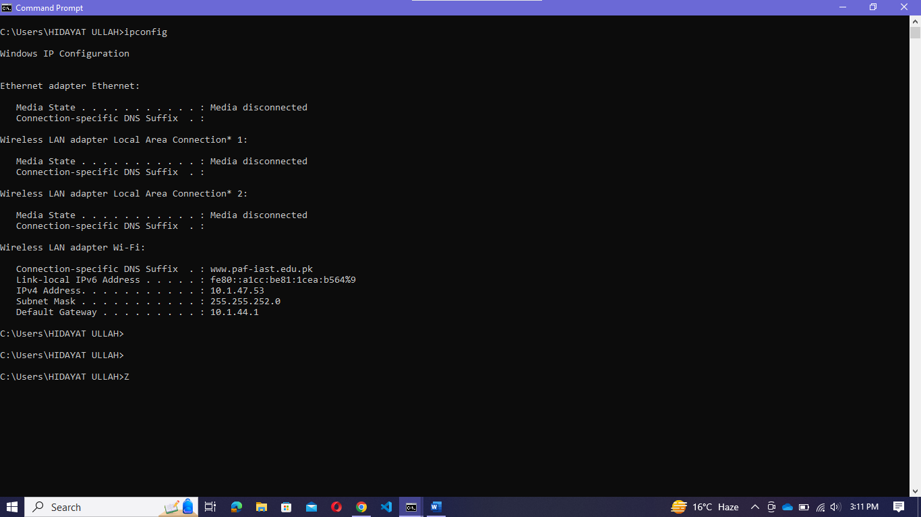

Fig.2: Command Screen for ipconfig

This first screen shows the IP address, subnet mask, and default gateway. The IP address and the

default gateway should be in the same network or subnet, otherwise this host would not be able to communicate outside the network. In the figure the subnet mask tells us that the first three octets must be the same to be in the same network.

Note: If this computer is on a LAN, the default gateway might not be seen if it is running behind a Proxy Server. Record the following information for this computer.

**Step 3 Record the following TCP/IP information for this computer**

IP address: _ 10.1.47.53______________________________________

Subnet Mask: ___255.255.252.0___________________________________________

Default Gateway: _ 10.1.44.1________________________________________________

Difference between Command.1 and .2: ________________________________________

**Step 4 Compare the TCP/IP configuration of this computer to others on the LAN**

If this computer is on a LAN, compare the information of several machines.

Are there any similarities? _yes____________

Same subnet mask? _______________yes_________

What is similar about the IP addresses? ___ 10.1.47__________________________________

What is similar about the default gateways? _____all__________________________________

The IP addresses should share the same network portion. All machines in the LAN should share the same default gateway.

Record a couple of the IP Addresses:

* IP Address of Machine 2: 10.1.47.53
* IP Address of Machine 1: 10.1.47.202

________________________________________________________________________

**Step 5: Check additional TCP/IP configuration information**

To see detailed information, type ipconfig /all and press Enter. The figure shows the detailed IP configuration screen.

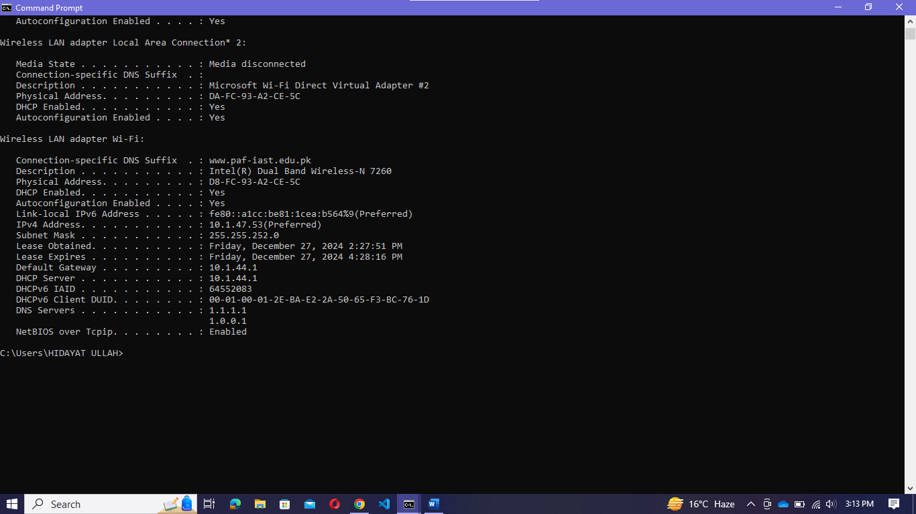

Fig.3: Command Screen for ipconfig /all

The host name, including the computer name and NetBIOS name should be displayed. Also, the

DHCP server address, if used, and the date the IP lease starts and ends should be displayed. Look over the information. Entries for the DNS, used in name resolution servers, may also be present.

The previous figure reveals that the router is performing both DHCP and DNS services for this network. This would likely be a small office or home office (SOHO) or small branch office implementation.

Notice the Physical Address (MAC) and the NIC model (Description):

**Computer 1:**

* **Physical Address (MAC)**: D8-FC-93-A2-CE-5C
* **NIC Model (Description)**: Intel(R) Dual Band Wireless-N 7260

**Computer 2:**

* **Physical Address (MAC)**: 94-E6-F7-F7-29-70
* **NIC Model (Description)**: Intel(R) Wi-Fi 6 AX200 160MHz

Write down the IP addresses of any servers listed:

* **DHCP Server**: 10.1.44.1
* **DNS Servers**: 1.1.1.1, 1.0.0.1

Write down the computer Host Name:

• Computer **1 Host Name**: DESKTOP-8QTRKLC

• Computer **2 Host Name**: DESKTOP-V8S8RAM

Write down the Host Names of a couple other computers:

* Host Name of Computer 1: DESKTOP-8QTRKLC
* Host Name of Computer 2: DESKTOP-V8S8RAM

Do all of the servers and workstations share the same network portion of the IP address as the student workstation? **Yes**, all workstations (10.1.47.xxx) and the DHCP server (10.1.44.1) share the same network portion as defined by the subnet mask 255.255.252.0. This means they belong to the same local network.

It would not be unusual for some or all of the servers and workstations to be in another network. It means that the computer default gateway is going to forward requests to the other network.

**Step 6 Close the screen**

Close the screen when finished examining network settings.

Repeat the previous steps as necessary. Make sure that it is possible to return to and interpret this screen.

Based on observations, what can be deduced about the following results taken from three computers connected to one switch?

Computer 1:

IP Address: 10.1.47.53

Subnet Mask: 255.255.252.0

Default Gateway: 10.1.44.1

Computer 2

IP Address: 10.1.47.202

Subnet Mask: 255.255.252.0

Default Gateway: 10.1.44.1

Computer 3

IP Address: 10.1.46.25

Subnet Mask: 255.255.252.0

Default Gateway: 10.1.44.1

Should they be able to talk to each other?

**Yes**, they should be able to communicate directly with one another because:

* All three computers share the same subnet mask (255.255.252.0), meaning they are part of the same network (10.1.44.0/22).
* They share the same default gateway (10.1.44.1) for routing traffic outside their network.

Are they all on the same network? Why or why not?

**Yes**, they are on the same network because:

* Their IP addresses fall within the range of the subnet defined by 255.255.252.0 (10.1.44.0 to 10.1.47.255).
* They share the same default gateway, indicating they are connected to the same router or switch.